============================================
Admin login to Developer Instance…for user Creation
admin
password
After login to instant …
Pune…..
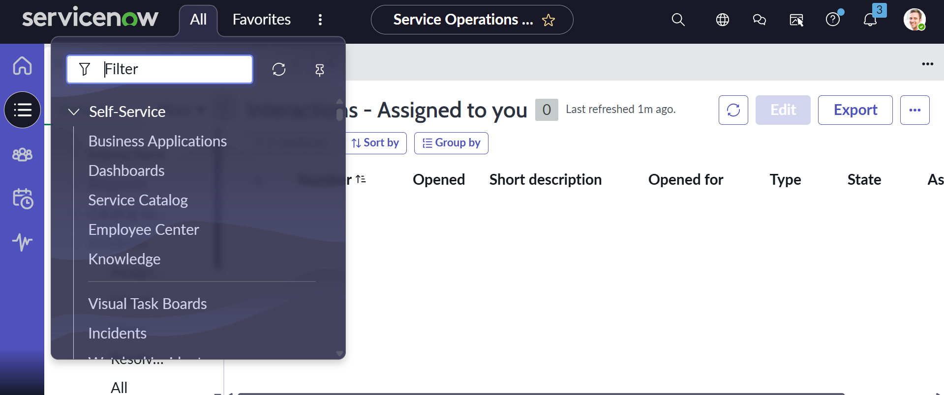

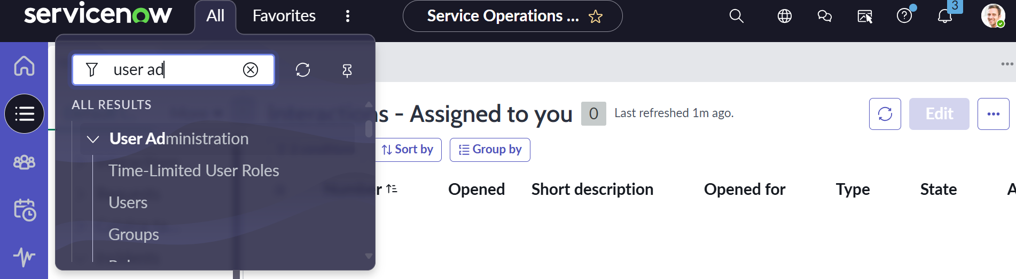
Click on Users and create New user….
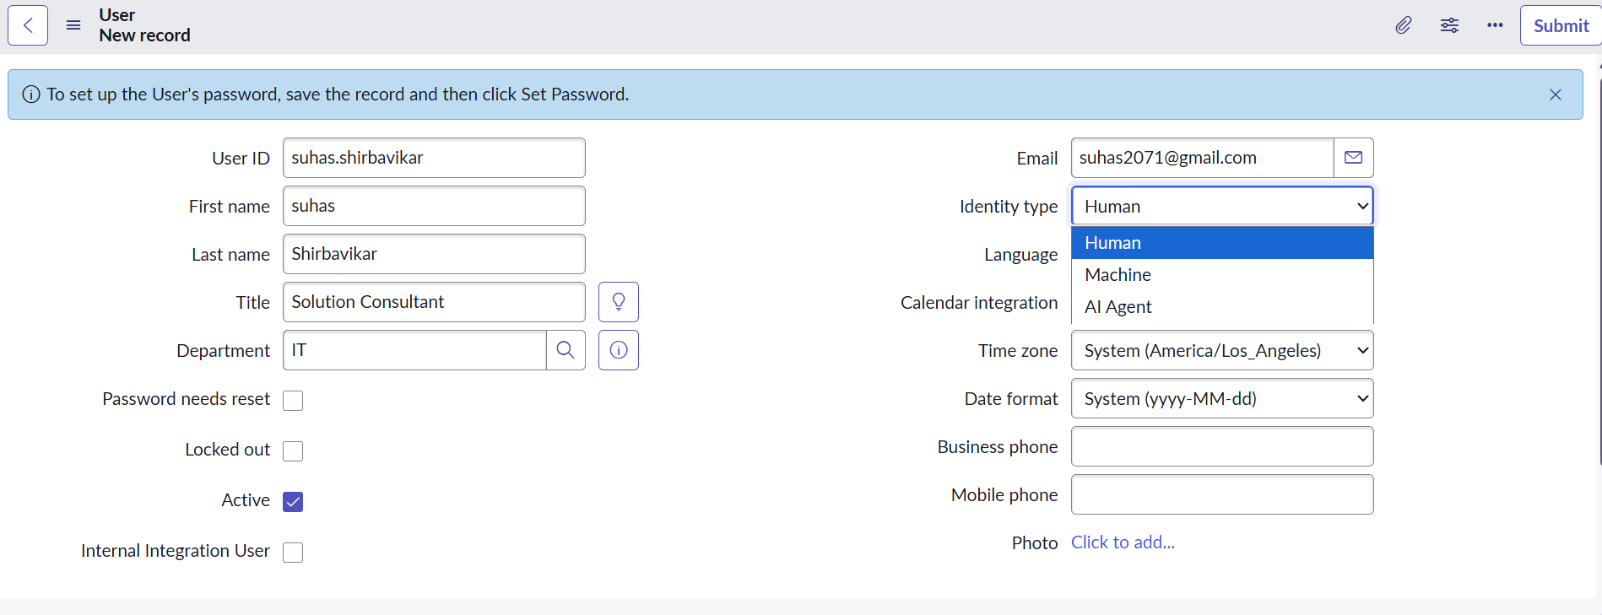
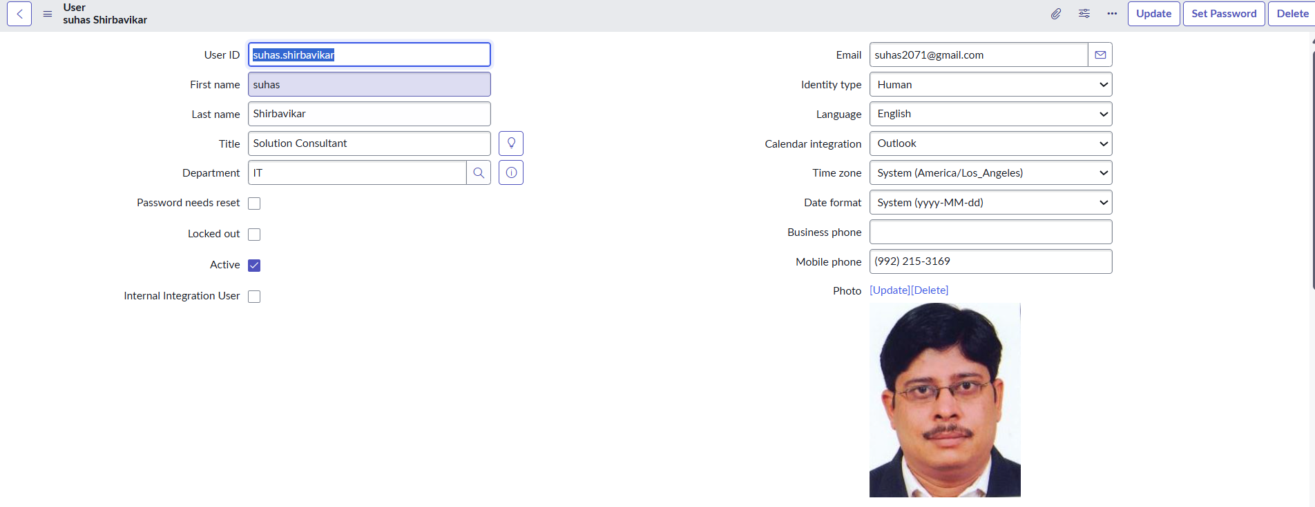
Scroll down… you will see Roles and Groups ….

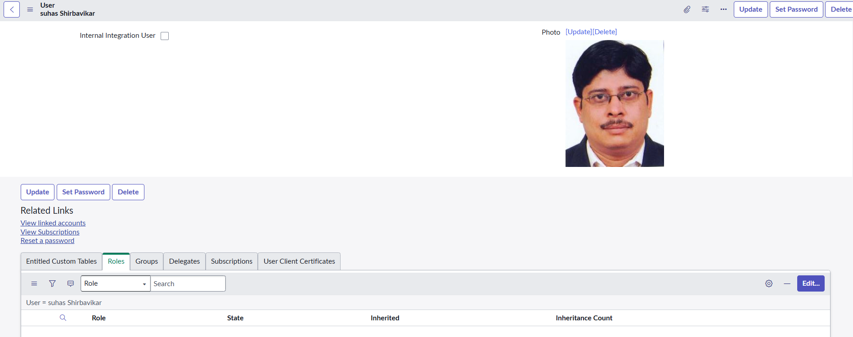
Click on Roles….and Edit….
F?N@}=hOBHHWmuQW$I<DCh3Kk&%6stUwSPiG8
vijay.arjunwadkar
Mumbai2025@

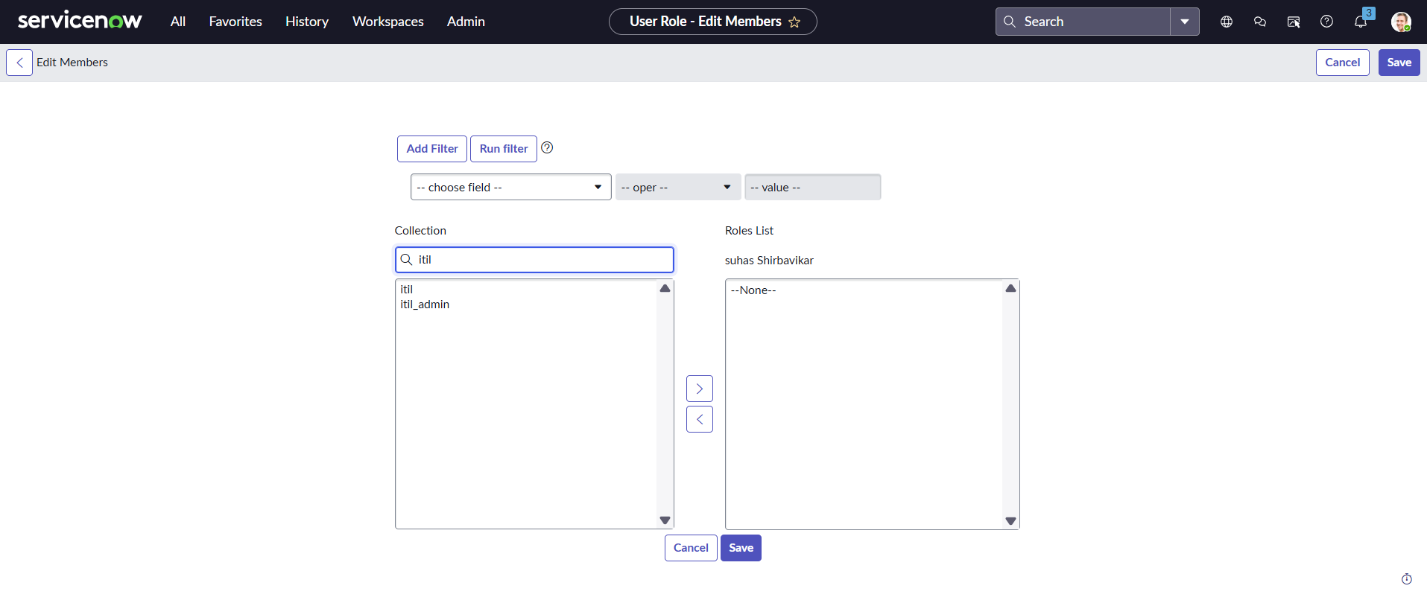
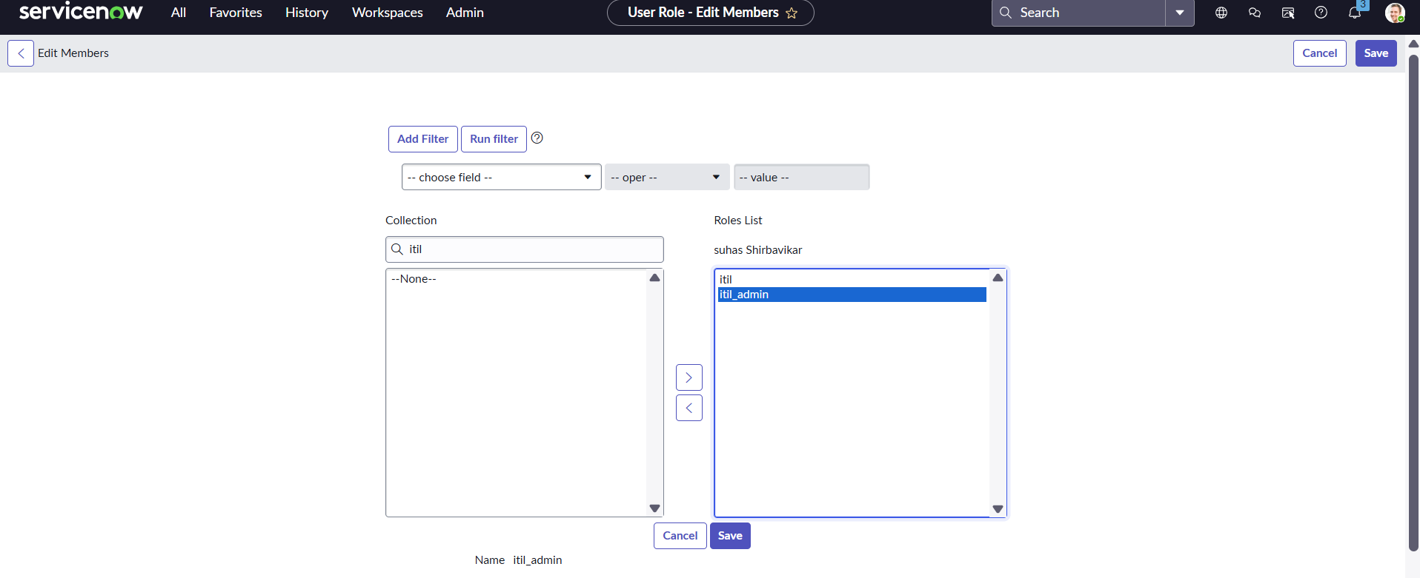
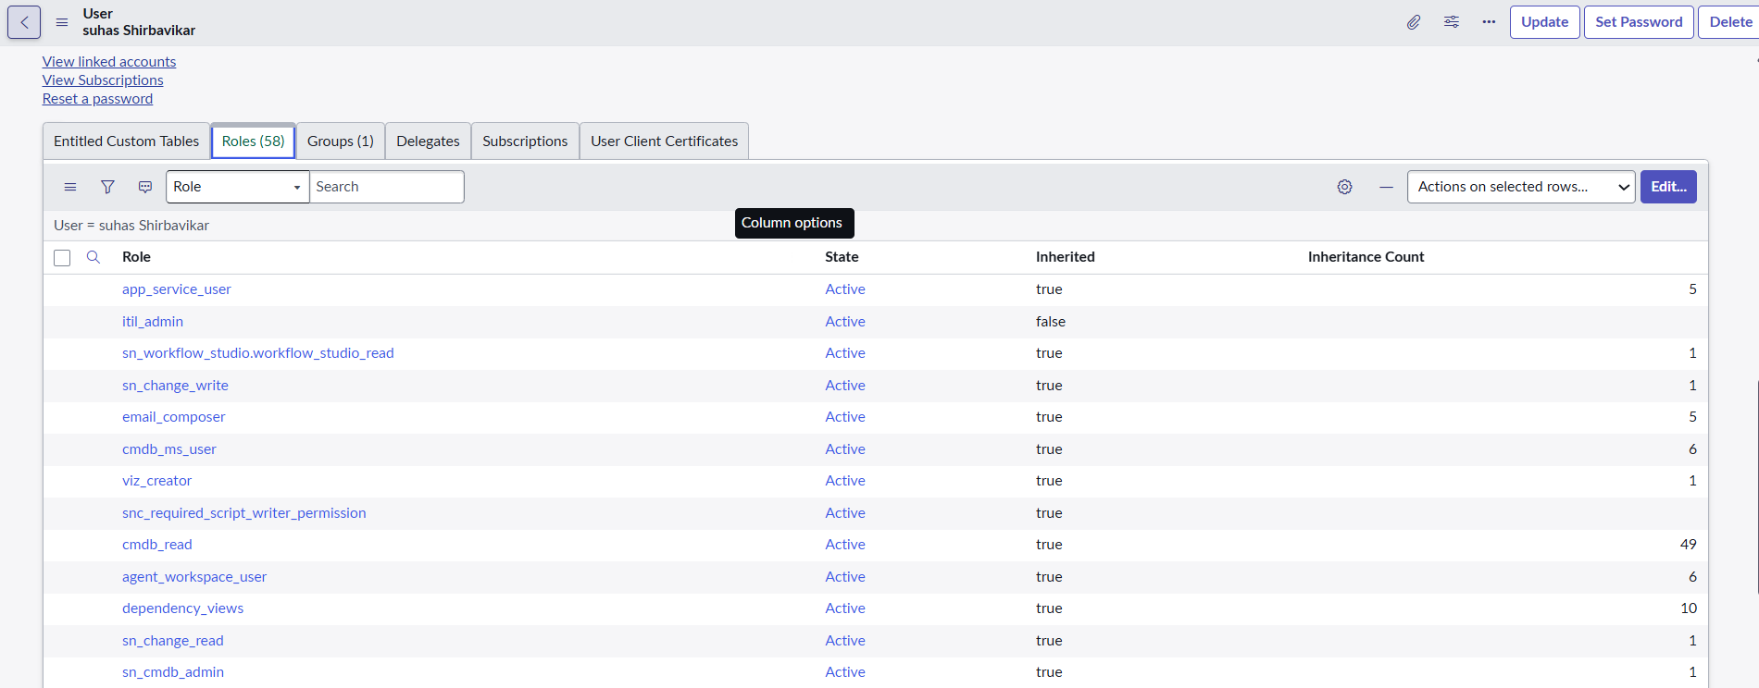
58 roles have been added…
Select Groups …. Click on Edit…..
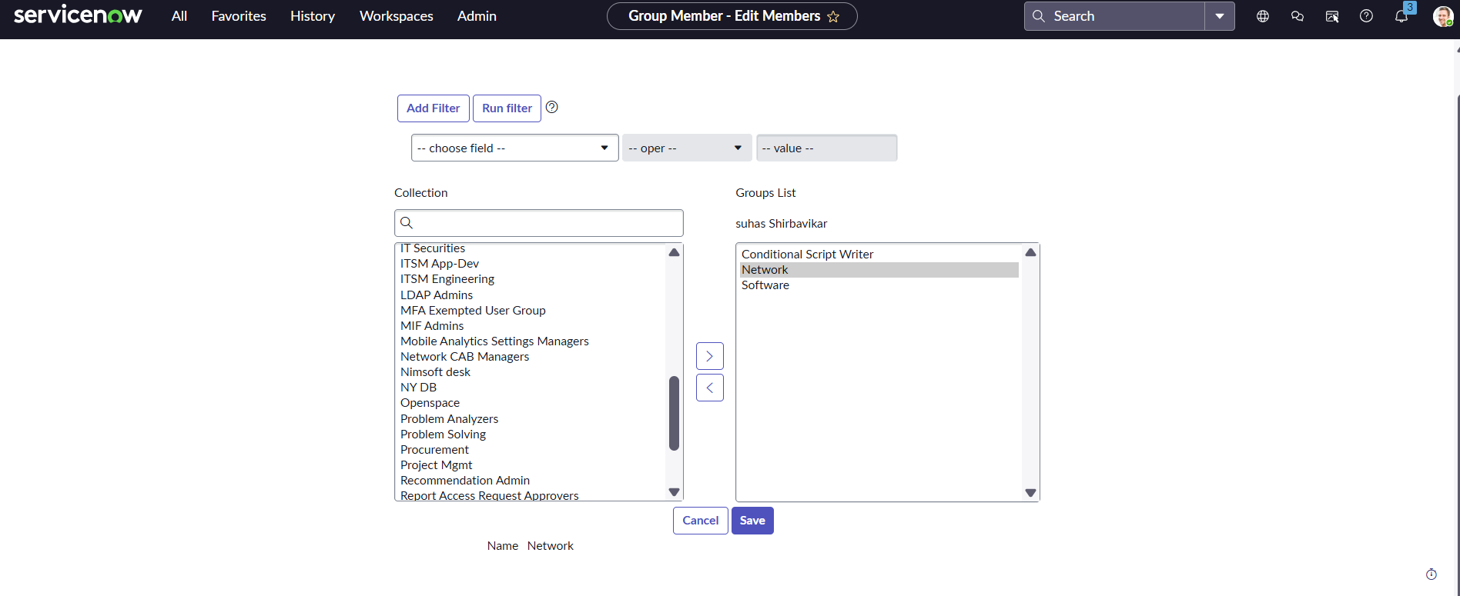
Added Suhas under Network and Software group …
Click on Save …
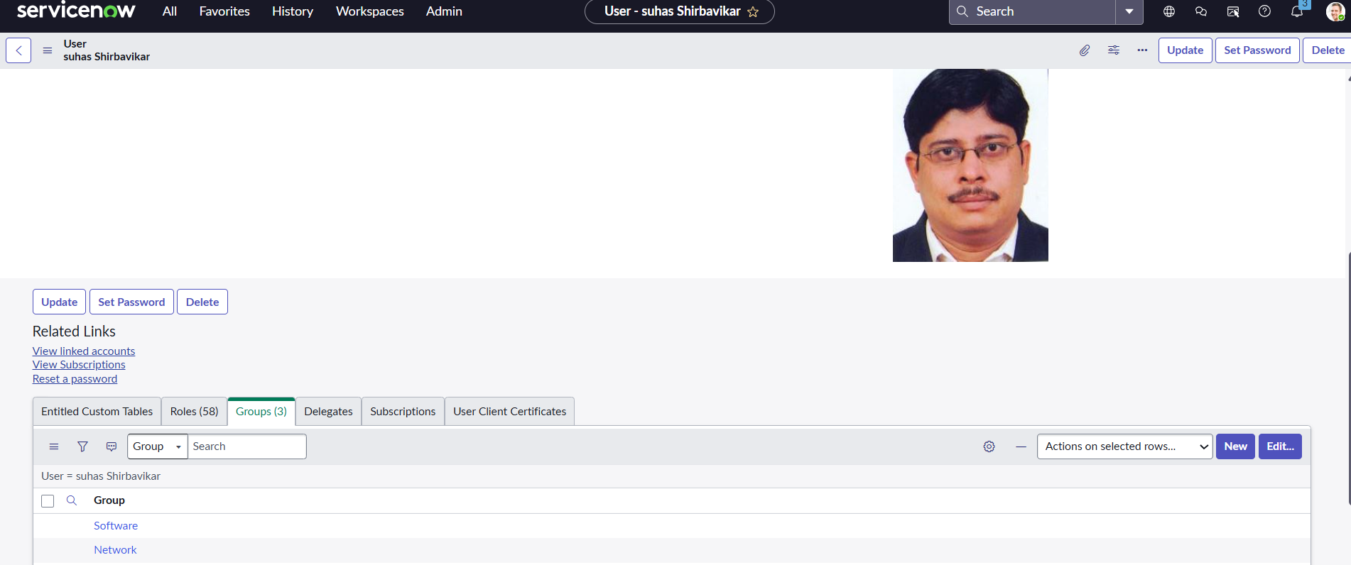
Click on Update ….
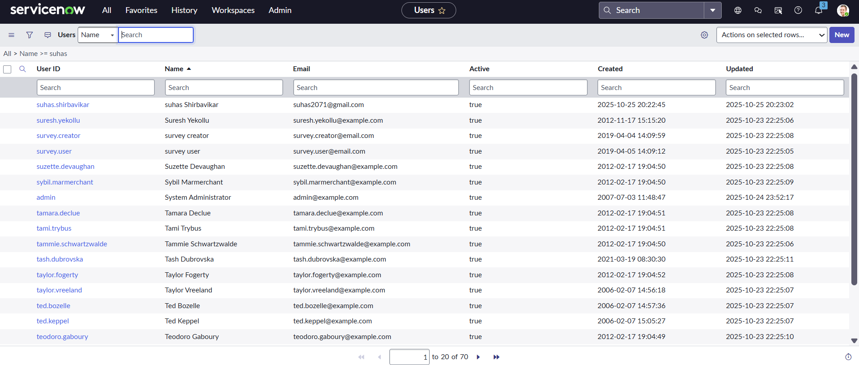
Now login through your name
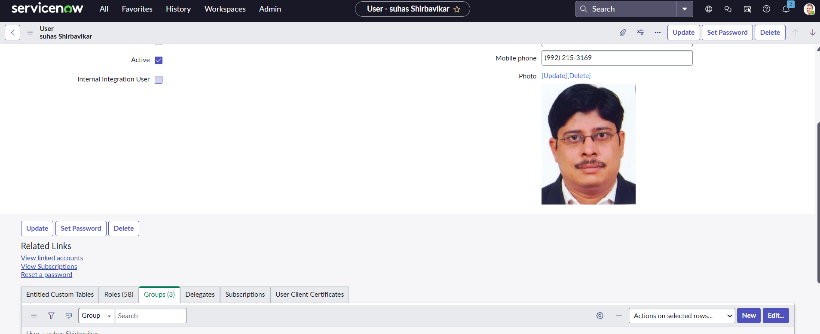
Click on Set Password….
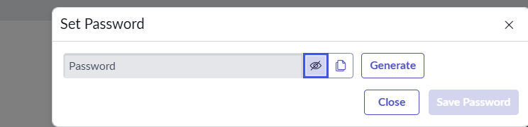
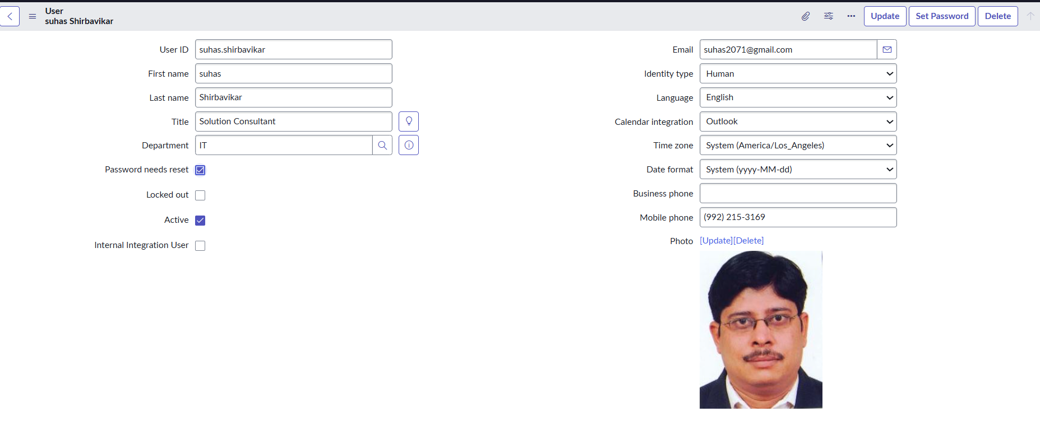
Selected Password needs reset….
Click on Update…
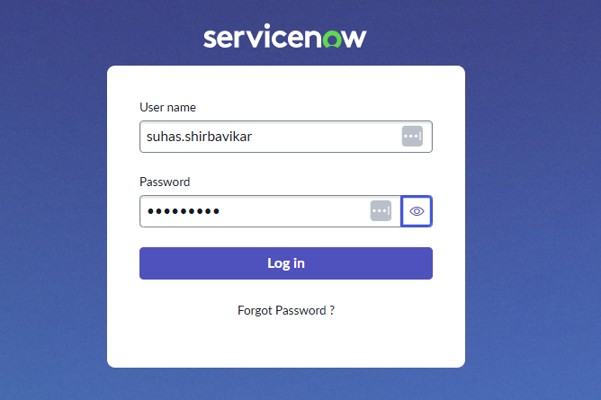

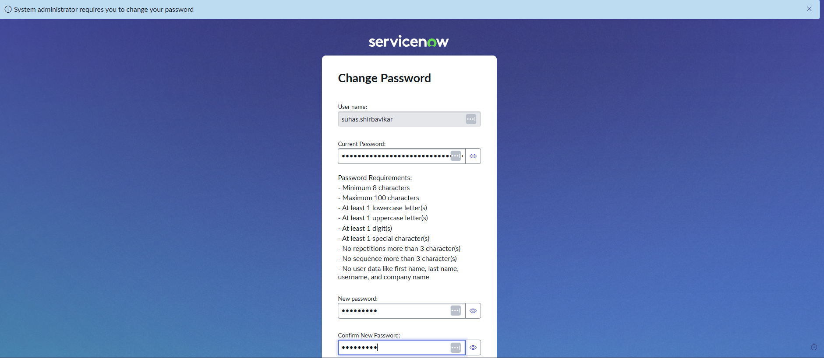
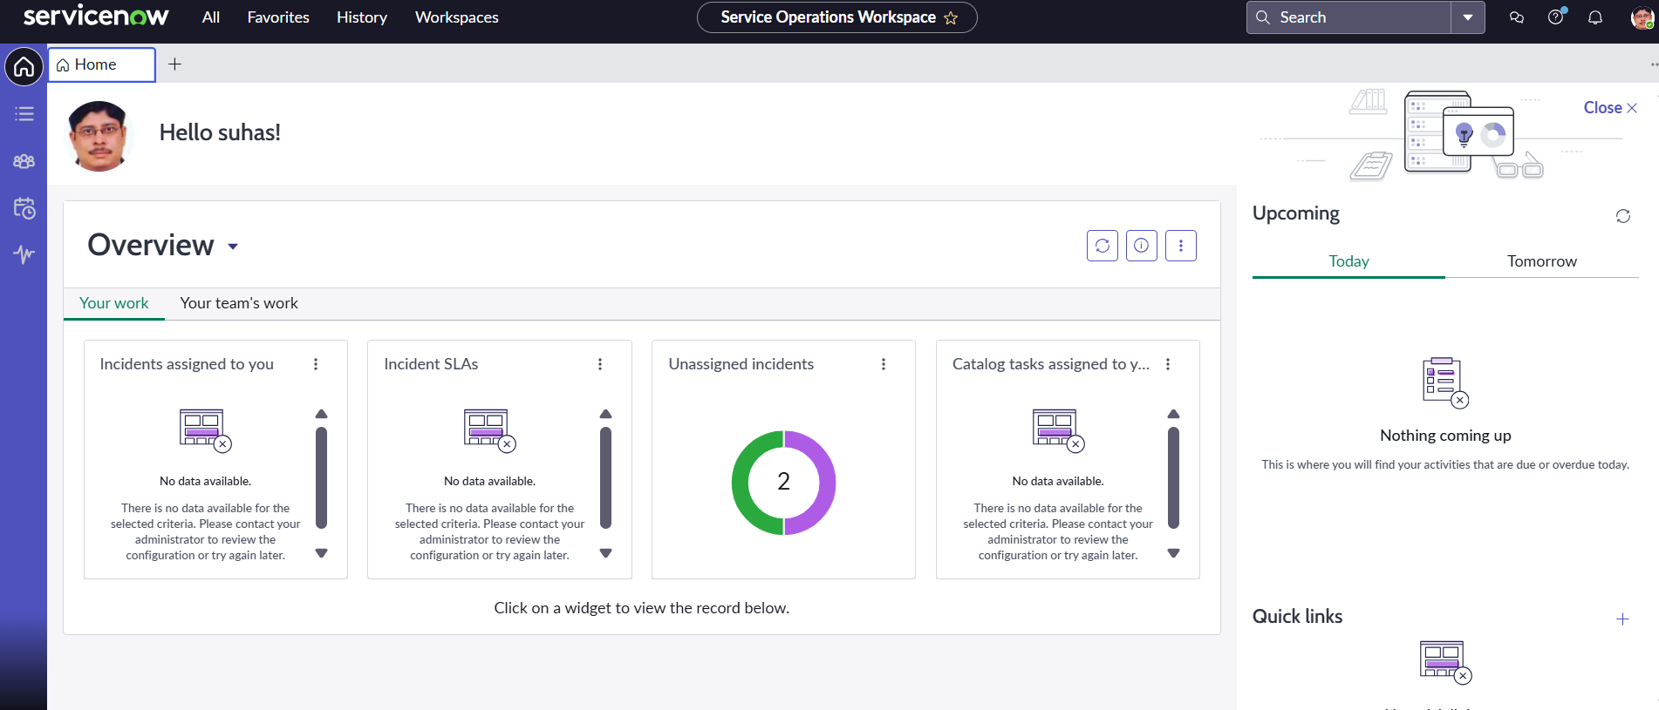
Pune……

